

|  |  |
| --- | --- |
| **Students** | **GH1043274 – Carl Jhon Odicta**  **GH1043557 – Renato Gean Pierre Leon Sanchez** |
| **Assessment Title** | **Impact of AI Tool Adoption to Compensation of Tech Professionals in Germany - Insights from the 2025 Developer Survey by Stack Overflow** |
| **Module Code** | **M506B** |
| **Module Title** | **Research Methods and Scientific Work** |
| **Module Tutor** | **Prof. Phungmayo Horam** |
| **Date Submitted** | **September 26, 2025** |

**Declaration of Authorship**

**We declare that all material in this assessment is our own work except where there is clear acknowledgement and appropriate reference to the work of others.**

**We fully understand that the unacknowledged inclusion of another person’s writings or ideas or works in this work may be considered plagiarism and that, should a formal investigation process confirms the allegation, I would be subject to the penalties associated with plagiarism, as per GISMA Business School, University of Applied Sciences’ regulations for academic misconduct.**

**Signed: Carl Jhon D. Odicta, Renato Leon**

**Date: 09.26.2025**

**Table of Contents**

1. Introduction 2

I.I. Research Question 3

I.II. Hypotheses 3

I.III. Scope and Limitation 3

I.IV. Significance of the Study 4

I.V. Definition of Key Terms 4

1. Literature Review 5

II.I. AI Tool Adoption and Compensation 5

II.II. Roles and Industry 6

II.III. Work Experience 7

II.IV. Conceptual framework 8

1. Methodology 9

III.I. Research Design 9

III.II. Data Source 9

III.III. Variables and Measurement 10

III.IV. Applied Filters 11

III.V. Data Analysis Plan 12

1. Data Presentation and Analysis 13

IV.I. Descriptive Statistics 13

IV.I. Data Analysis 16

RQ1. AI Tool Adoption Effect on Compensation 16

RQ2. Moderating Effect of Role and Industry 18

RQ3. Mediating Effect of Work Experience 20

1. Conclusion and Recommendation 24
2. List of Tables 25
3. List of Figures 25
4. References 26

**“Impact of AI Tool Adoption to Compensation of of Tech Professionals in Germany – Insights from the 2025 Developer Survey by Stack Overflow”**

1. **Introduction**

I.I. **Background of the Study**

In Germany, Tech professionals are expected to keep up with the rapidly evolving work environment where several tools are being introduced. Most of these tools utilizes AI technologies and are quickly advancing, thus, continuous upskilling for workers is almost mandatory and standard. Around 41% of German companies now use AI in their operations, particularly in IT services, reflecting a shift in workplace practices and expectations for tech workers (ifo.de, 2025).

In general, the effects of AI in the workforce are both positive and challenging. Studies shows AI adoption can improve productivity and innovation (Czarnitzki D., 2023). Additionally, 91% of German companies consider AI critical for business growth (KPMG, 2025). On the other hand, some studies also suggest AI can create stress, skill displacement, or devaluation of workers’ contributions when perceived that AI does majority of their work (Schweitzer S., 2025).

AI can significantly aid work for tech professionals. Tools like GitHub, Copilot, Collab, or other AI assistants can help in automation and coding, which enables more time to be allocated in higher-level tasks such as problem solving and decision making. These improvement in productivity could translate to compensation and rewards when highlighted and recognized.

AI adoption in Germany is increasing among tech professionals both in large and small sized organizations. This opens the question to whether individual’s AI usage translates into any career advantages, since at the company-level, AI adoption is already linked to higher revenue and improved productivity. Despite the growing evidences for the company-level, research gaps remain regarding individual-level correlation between AI adoption and compensation. This study aims to look into this gap and also consider the effects of professional roles, industry, and work experience.

Data from the 2025 Developer Survey by Stack Overflow will be used in this study. It includes respondents’ information on AI tool usage, gross total annual compensation, professional role, industry, work experience, and other demographic variables that will be used as controls. This dataset will allow the use of cross-sectional quantitative data analysis of the AI Tool Adoption effects, role and industry-based moderation, and mediation by work experience.

This study will contribute new understanding on individual-level effects of AI adoption which could be helpful in career decision making and development, and in organizational compensation policies for tech professionals.

**I.II. Research Questions**

Primary Question:

Q1. How does AI tool adoption affect compensation among tech professionals in Germany?

Secondary Questions:

Q2. Does the compensation effect of AI adoption vary across roles and Industry?

Q3. Does work experience mediate the relationship between AI tool adoption and compensation?

**I.III. Hypotheses**

Primary Hypothesis:

H10: There is no significant difference in compensation regardless of frequency of AI tool use.

H11: There is a significant difference in compensation depending on frequency of AI tool use.

Secondary Hypotheses:

H20: There is no significant difference on the effect of AI tool adoption on compensation across professional roles and industry.

H21: There is a significant difference on the effect of AI tool adoption on compensation across professional roles and industry.

H30: Work experience does not mediate the relationship between AI tool adoption and compensation.

H31: Work experience have a mediating effect in the relationship between AI tool adoption and compensation.

**I.IV. Scope and Limitation**

Scope:

This study focuses on exploring the relationship between AI tool adoption and compensation among technology professionals in Germany.

Specifically, it examines:

1. The effect of AI tool adoption on individual compensation.
2. How this effect varies across professional roles and industry.
3. The mediating role of work experience.

Limitations:

This study uses the data from the 2025 Developer Survey by Stack Overflow, filtering in only the respondents from Germany who reported their total gross annual compensation in Euros. This dataset implies the following limitations:

1. Cross-sectional data – Answers were given and collected at a single point in time.
2. Self-reported data – Survey answers were made by the respondents and was not verified which may introduce biases and inaccuracies.
3. Demographic – Analysis is filtered only to include tech professionals in Germany.

**I.V. Significance of the Study**

The results of this study will give important insights on multiple levels:

* Practical Significance

Tech professionals will gain actionable insights on how adopting AI tools may influence their potential compensation, this can serve as guidance in career decisions, skill development, and use of AI professionally.

Organizations can use the insights from this study in building human resource policies on performance evaluation, training programs, and compensation structures.

* Theoretical Significance

This study will give insights on the individual-level impact of AI tool adoption on compensation in the German technology sector. The results will provide better understanding on how AI adoption could potentially shape economic rewards and compensation.

This study and its methodologies can be used as basis for future research.

**I.VI. Definition of Key Terms**

Following are terms/phrases that will be used frequently in this study.

1. AI Tool Adoption – Respondent’s frequency of using AI tools during their development process (0- never and not willing to use, 1- never but willing to use, 2- monthly, 3-weekly, or 4-daily).
2. Compensation – Total gross annual salary in Euro.
3. Roles – Job title (i.e. Data analyst, developer, project manager, etc. Including also “student”)
4. Industry – Purpose or specific task where the respondent use AI. (i.e. customer service, analytics, IT, marketing, etc.)
5. Work Experience – Total years of professional work experience

1. **Literature Review**

**II.I. AI Tool Adoption and Compensation**

Literature 1.

*Engberg E. (2025). "Artificial Intelligence, Tasks, Skills, and Wages: Worker-level Evidence from Germany."*

“This paper[literature] examines how new technologies are linked to changes in the content of work and individual wages”. By investigating how AI adoption affects individual wages of workers in Germany - focusing on task content and skill requirements - this study was able to highlight that “AI and automation exposure is associated with both detailed changes in what workers do at work and changes in earnings.”

Takeaway: AI adoption leads to wage differences among employees. Benefiting high-skill workers while potentially disadvantaging low-skill workers.

Literature 2.

*Kim J., et al. (2025). "People Reduce Workers' Compensation for Using Artificial Intelligence (AI)."*

This literature “investigates whether and why people might reduce compensation for workers who use AI tools. Across 10 studies, participants consistently lowered compensation for workers who used AI tools. This “AI Penalization” effect is robust across different type of work and work status.”

Takeaway: The "AI Penalization" effect, as coined in this study, suggests that workers utilizing AI tools may face reduced compensation due to perceptions of lower value.

Literature 3.

*Stephany F., & Teutloff O. (2022). "What is the Price of a Skill? The Value of Complementarity.”*

“This literature highlights the importance of constant reskilling as in accordance to global workforce demands, particularly towards technological changes, it is essential to invest in the right skills.”

“We demonstrate that the skills’ value is strongly determined by complementarity - that is, how many different skills, ideally of high value, a competency can be combined with.” Findings show that “AI skills are particularly valuable - increasing worker wages by 21% on average - because of their strong complementarities and their rising demand in recent years.”

Takeaway: AI skills are valuable and could translate to increase in worker wages, due to its “strong complementarities and rising demand”.

Literature 4.

*Spence M. (1973). “Job Market Signaling. The Quarterly Journal of Economics”*

This literature explores the applications of “Signaling theory” which suggests that “observable characteristics (signals) help employers identify high-productivity workers when actual productivity is difficult to observe directly.”

Takeaway: AI tool adoption may signal higher productivity, and that compensation premiums could be independent of actual productivity.

Literature 5.

*Peng S., et al. (2023). “The Impact of AI on Developer Productivity: Evidence from GitHub Copilot”*

This literature is a large-scale study of 12,000+ developers showing around 55% faster task completion with GitHub Copilot, with stronger effects for junior developers and routine tasks. This shows significant productivity gains across multiple programming languages, larger benefits for repetitive coding tasks, but mixed effects on code quality.

Takeaway: Utilizing AI tools shows significantly faster task completion among developers. Therefore, using AI does have actual productivity gains.

From the takeaways in this section, we are supported that there are observable relationship between AI adoption and compensation. There are studies supporting both positive and negative correlation between these variables, but regardless of the direction of the relationship, we can hypothesize that there could be a relationship among them.

Additionally, Signaling theory suggests that compensation is independent of actual productivity, adding that to studies actually showing productivity gains brought about AI tool usage, we can say that actual productivity is not significant.

**II.II. Roles and Industry**

Literature 6.

*Stephany F., Mira A., & Bone M. (2025). “Beyond pay: AI Skills Reward More Job Benefits.”*

“This study investigates the non-monetary rewards associated with artificial intelligence (AI) skills in the U.S. labour market.” Findings suggests that roles demanding AI skills are more likely to offer higher pay and better benefits despite occupation, industry, and education remains constant.

Takeaway: Roles demanding higher AI skills have better compensation.

Literature 7.

*PwC. (2025). “PwC 2025 Global AI Jobs Barometer”. Pwc.com*

“AI linked to a fourfold increase in productivity growth and 56% wage premium, while jobs grow even in the most easily automated jobs”. This literature from Pwc, a global professional services firm, says that industries more exposed to AI have seen large increase in productivity and wages.

Takeaway: Industries that adopt AI provides more opportunity and wages.

Industries more exposed to AI has faster and larger revenue gain, therefore roles within these industries that uses AI more regularly are also rewarded better

**II.III. Work Experience**

Literature 8.

*Dorta-González P., et al (2024). “Generative Artificial Intelligence Usage by Researchers at Work: Effects of Gender, Career Stage, Type of Workplace, and Perceived Barriers.”*

“This paper[literature] seeks to explore the factors underlying the frequency of use of generative AI amongst researchers in their professional environments.” Results shows that career stage, workplace type, and barriers strongly predict usage.

Takeaway: Career Stage (Work experience) influence AI use.

Several variables identified in the literature in this section are also used in this study such as, age, educational level, work set-up, and company size. Literature 8 shows that work experience is a significant variable in AI tool usage which sparks interest in the researcher of its mediating effect.

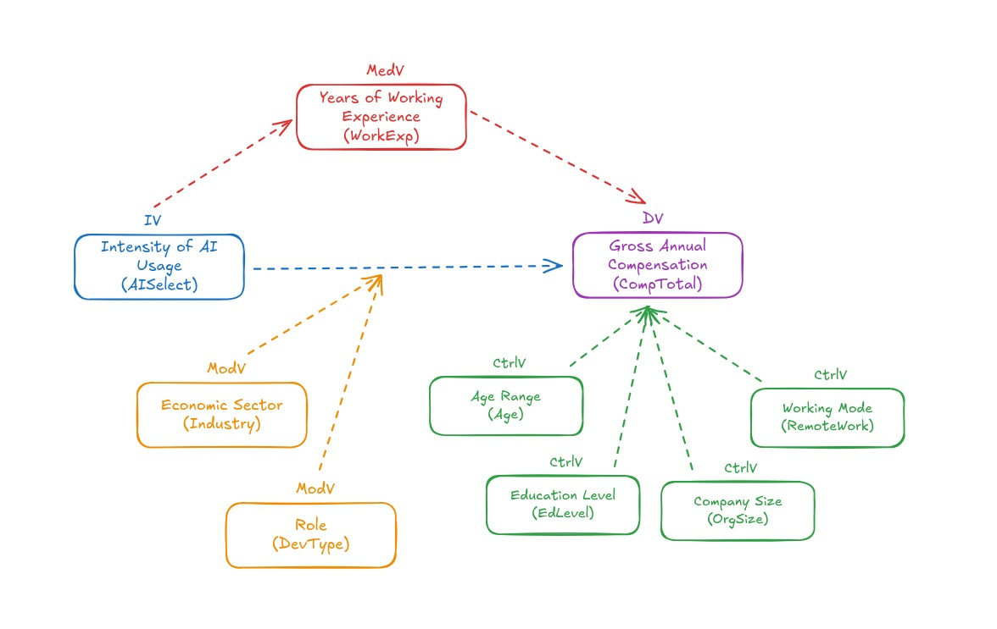 **II.IV. Conceptual Framework**

Figure 1. Conceptual Framework

1. **Methodology**

**III.I. Research Design**

Research Philosophy: Positivism

This study follows a positivist philosophy, which believes that reality is objective and measurable. In line with positivism, relationships between variables such as AI tool adoption, compensation, role, industry, and work experience exists regardless of individual interpretations, therefore, it justifies the use of data and statistical tests to derive generalizable insights for tech professionals in Germany.

Research Strategy: Quantitative

This study follows a quantitative strategy, using ordinal and scale data as variables of interest, collected through the 2025 Developer Survey by Stack Overflow.

Research Approach: Deductive

This study follows a deductive approach, creating hypotheses based on the results of prior literatures relating AI adoption and compensation. These hypotheses are then tested using quantitative analysis applied to the 2025 Developer Survey dataset. “Deductive reasoning begins with established theories and prior research findings, from which specific hypotheses are derived and subjected to empirical testing” (Bryman, 2016).

**III.II. Data Source**

This study will use a secondary dataset from the **2025 Developer Survey** by Stack Overflow.

“The 2025 Developer Survey is the definitive report on the state of software development. In its fifteenth year, Stack Overflow received over 49,000+ responses from 177 countries across 62 questions focused on 314 different technologies, including new focus on AI agent tools, LLMs and community platforms.”

Website: <https://survey>.stackoverflow.co/2025

Dataset: <https://survey.stackoverflow.co/datasets/stack-overflow-developer-survey-2025.zip>

**III.III. Variables and Measurement**



Table 1. List of Variables

**III.IV. Applied Filters**

Filter was used to only include responses from the target population. A final sample size of 1859 responses were included after applying the following filters:



Table 2. List of Applied Filters

**III.V. Data Analysis Plan**



Figure 2. Data Analysis Plan

1. **Data Presentation and Analysis**

**IV.I. Descriptive Statistics**

We check continuous and nominal/ordinal variables separately. For our statistical tests to work we must satisfy normality for our data. (Besides CLT) We do this by checking for skewness and standardizing, and by removing outliers.

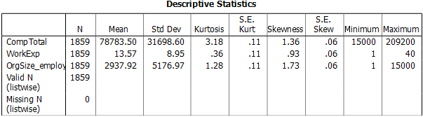

Figure 3. Descriptive Statistics (Continuous Variables)

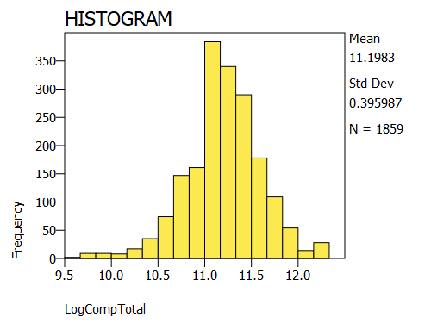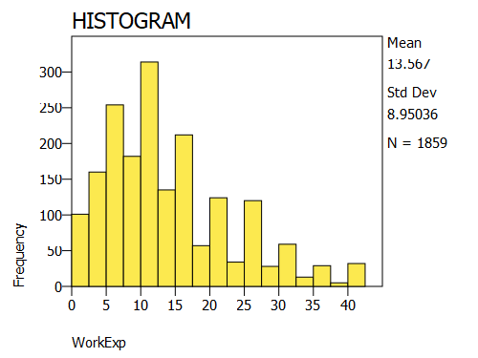 To correct high skewness (>1), we perform log transformation. Using log(CompTotal) and log(Orgsize_employees) in our models instead.

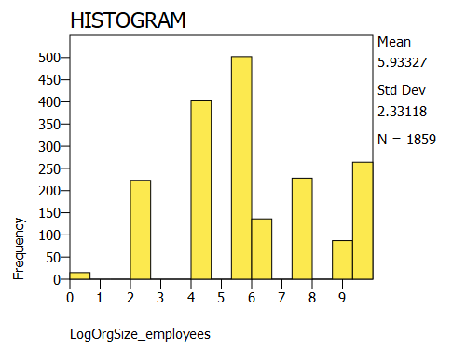

Figure 4. Histogram (Continuous Variables)

From visual inspection we can see that the histograms are bell-shaped and centered which suggests normality and no outliers.

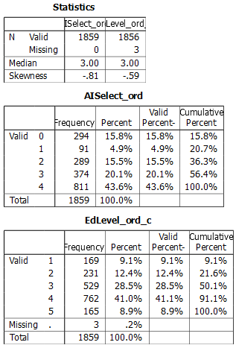

Figure 5. Descriptive Statistics (Ordinal Variables)

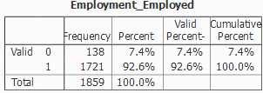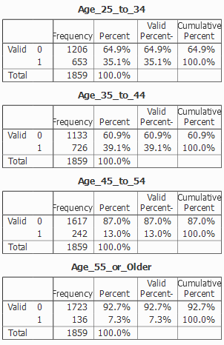 Ordinal variable check for AISelect and EdLevel. After grouping “primary” and “secondary”, and “some college” and “associate degree” together, Figure 5 shows all levels have >5% sample size. AISelect was also centered so that it’s mean will be around 0.

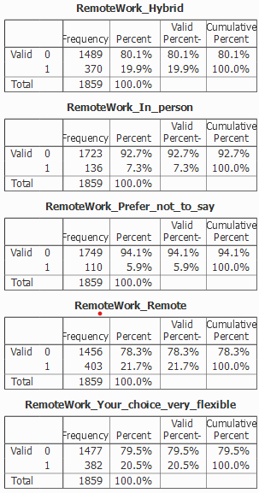

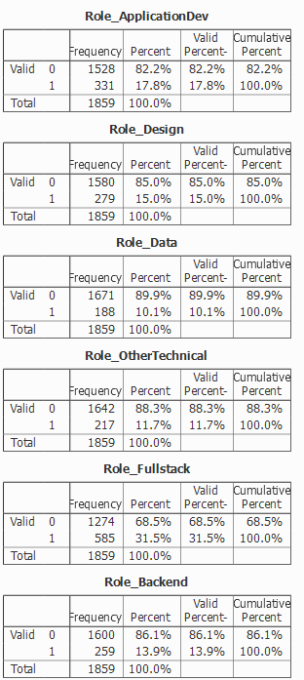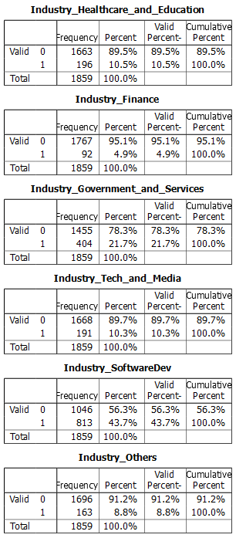

Figure 6 Descriptive Statistics (Nominal Variables)

The original dataset contains several more categories for age group, devtype, and industry. However, we group them based on similarity to ensure that each categories has sufficient sample sizes (>5%) . Figure 6 shows the final groupings.

**IV.II Data Analysis**

We will divide this section into three(3) parts answering each research question.

**RQ1. AI Tool Adoption Effect on Compensation**

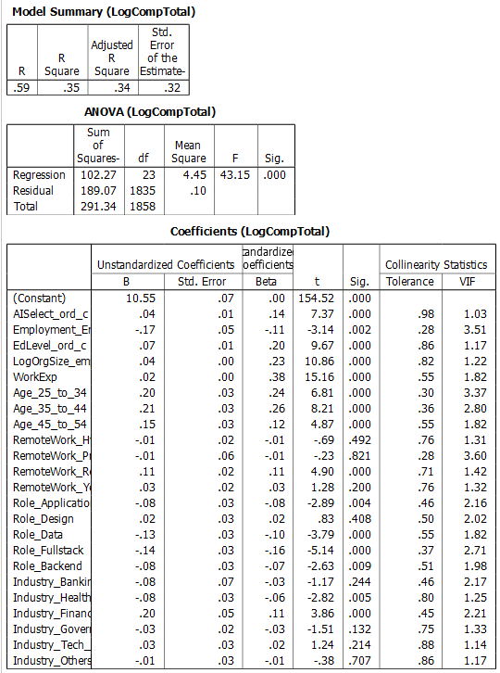

Figure 7. Model 1: Main Effects

We will analyze the main effect of AI Tool Adoption to Compensation with a regression model. Results shows that AI Tool Adoption has a statistically significant positive effect to Compensation, with an increase by around 4% in compensation per unit increase in AI Tool Adoption, with all the other variables constant. If we apply that into the extreme scenario, we can say that Tech professionals who use AI daily earn roughly 17% more than those who never use AI, controlling for all other factors.

The model only explains around 35% of the differences in Compensation (R2=0.35), which could be reasonable since compensation can be influenced by many unmeasured factors (i.e. company policies, other skills, etc.) VIF close to 1 means that it is not highly correlated with the other predictors so coefficient estimates are reliable

Post-hoc Analysis for Model 1

To ensure that the model shows unbiased coefficients and correct significance test, we perform post-hoc analysis to confirm normality and homoscedasticity of the residuals.

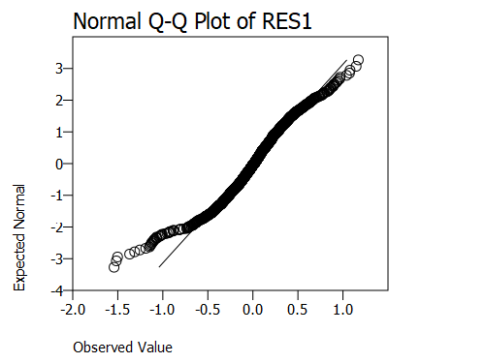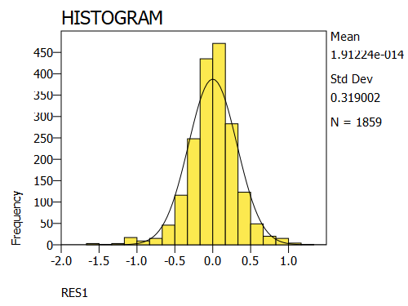

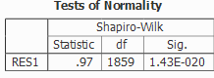

Figure 8. Model 1: Normality of Residuals

Through visual check we can see that the histogram follows a bell-shaped curve and the Normal Q-Q Plot approximately follows a straight line, this suggests normality of residuals, which is further supported by the Shapiro-Wilk test with P-value > 0.05 means residuals do not significantly deviate from normality.

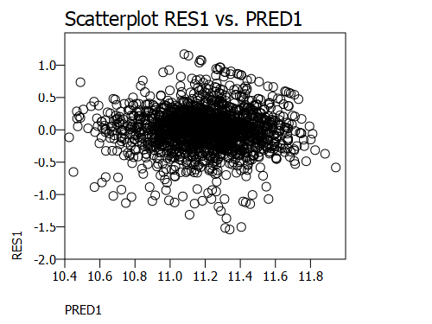

Figure 9. Model 1: Homoscedasticity

From inspection of the scatterplot between residuals and predicted values, we can see scattering of points and no pattern which supports model assumption of homoscedasticity.

**RQ2. Moderating Effect of Role and Industry**

Moderating effect means that the strength of the effect of AI Tool Adoption to Compensation is different across different roles and industries.

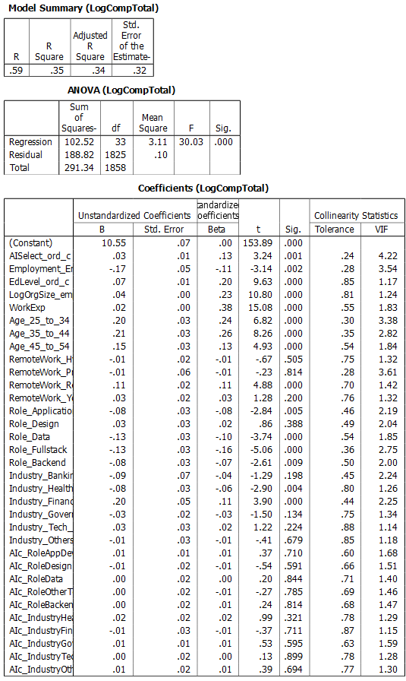



Figure 10. Model 2: Interaction Effects

To test for the moderating effects of roles and industry to the AI Tool Adoption effect to Compensation, we create regression model with interaction terms between AI Tool Adoption and each category of role and industry.

Adding interaction terms between AI Tool Adoption and Role/Industry did not improve model fit (still at 35%). The main effect of AI Tool Adoption remained positive and significant. None of the interaction terms were significant, suggesting that the effect of AI Tool Adoption on compensation does not vary across developer types or industries. Therefore, moderation by Role or Industry is not supported

Post-hoc Analysis for Model 2

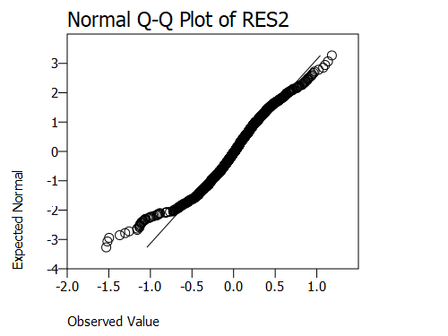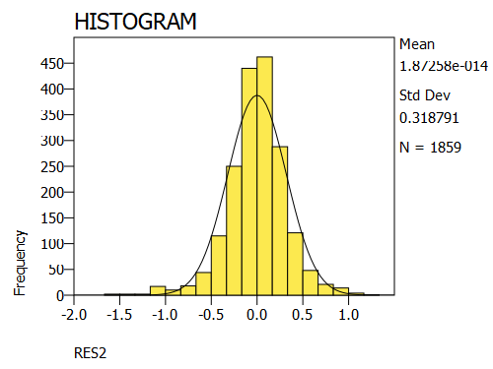 Similarly, we run the post-hoc analysis for Model 2 to confirm normality and homoscedasticity of residuals.

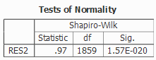

Figure 11. Model 2: Normality of Residuals

Using similar inspection as before, a bell-shaped curve historgram, linear Q-Q plot of residuals, and not significant shapiro-wilk test supports normality of the error terms.

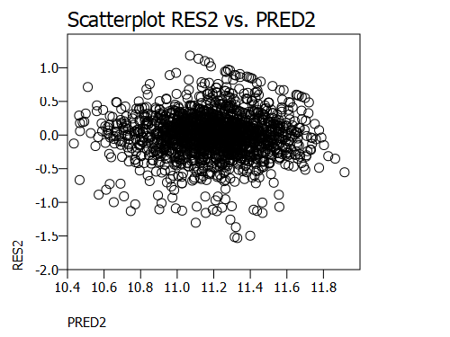

Figure 12. Model 2: Homoscedasticity

Scatterplot of residuals and predicted values are evenly scattered supporting homoscedasticity of residuals.

**RQ3. Mediating Effect of Work Experience**

Mediation effect means that AI Tool Adoption affects Work Experience, which in turn affects Compensation. To prove this we will follow the Baron & Kenny Approach where we run a series of linear regressions to establish the mediation effect.

The path is as follows:

Path A: AI Tool Adoption → Work Experience

Path B: Work Experience → Compensation (controlling for AI Tool Adoption)

Path C: Total effect: AI Tool Adoption → Compensation (without mediator)

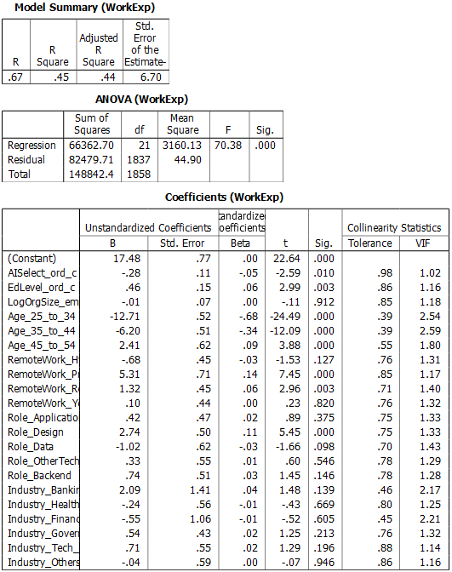Path D: Direct effect: AI Tool Adoption → Compensation (with mediator)



Figure 13. Model 3: Path A

From Path A, AI Tool Adoption has a significant effect to Work Experience.





Figure 14. Model 4: Path B

Controlling for AI Tool Adoption, our mediating variable, Work Experience has a significant effect to Compensation, based on Path B.

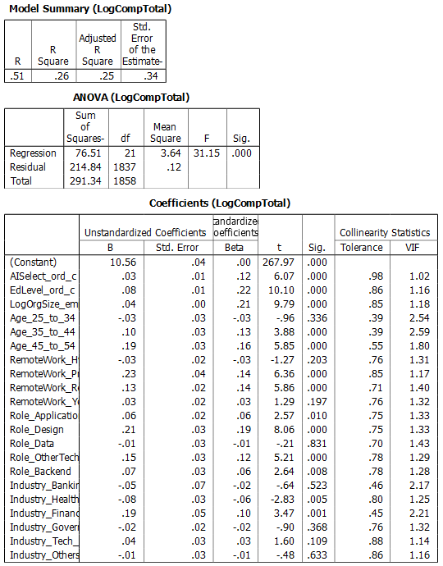



Figure 15. Model 5: Path C

From Path C, it shows that AI Tool Adoption has an effect to Compensation without including the mediating variable. This is the direct effect of AI Tool Adoption to Compensation. Also, note that the coefficient is 0.03 in this model.

]

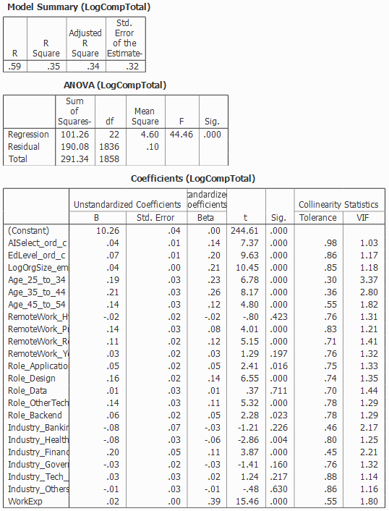



Figure 16. Model 6: Path D

Path D also shows significant effect of AI Tool Adoption to Compensation with the mediating variable, work experience included in the model.

When Work Experience was added to the model, the coefficient of AI Tool Adoption increased rather than decrease, this suggests that Work Experience does not mediate the relationship between AI Tool Adoption and Compensation in the expected way. Instead, Work Experience appears to act as a suppressor variable, revealing a stronger direct effect of AI Tool Adoption on compensation once differences in work experience are accounted for.

1. **Conclusion and Recommendation**

**V.I. Summary of findings**

From our analysis we have the following results

1. There is a significant difference in compensation depending on frequency of AI tool use. With an increase of around 4% in compensation for each unit increase in AI Tool Adoption.
2. There is no significant difference on the effect of AI Tool Adoption on Compensation across roles and industry.
3. Work Experience have a suppressing effect in the relationship between AI Tool Adoption and Compensation.

**V.II. Conclusion**

Frequent use of AI consistently relates to higher compensation. This effect is stable across industries and job roles, showing that AI adoption is a general advantage in the labor market rather than one limited to specific groups. While AI users tend to have more work experience, experience does not explain away the pay difference. Instead, AI skills contribute independently to higher compensation, even after accounting for experience and other job-related factors.

In conclusion, adopting AI tools is linked to a meaningful salary increase, no matter your role, industry, or level of experience.

**V.III. Recommendation for future research**

* Reflecting this study’s limitations, future research could use more verified data and add more variables in the model to explain the relationships in the variables.
* More advanced regression techniques could be used, seeing that this study only used simple OLS regression which could have been influenced by outliers.
* Conduct further studies on how to convince people to start using AI in their everyday work regardless of their role, industry, and work experience.

**List of Tables**

Table 1. List of Variables 10

Table 2. List of Applied Filters 11

**List of Figures**

Figure 1. Conceptual Framework 8

Figure 2. Data Analysis Plan 12

Figure 3. Descriptive Statistics (Continuous Variables) 13

Figure 4. Histogram (Continuous Variables) 13

Figure 5. Descriptive Statistics (Ordinal Variables) 14

Figure 6 Descriptive Statistics (Nominal Variables) 15

Figure 7. Model 1: Main Effects 16

Figure 8. Model 1: Normality of Residuals 17

Figure 9. Model 1: Homoscedasticity 17

Figure 10. Model 2: Interaction Effects 18

Figure 11. Model 2: Normality of Residuals 19

Figure 12. Model 2: Homoscedasticity 19

Figure 13. Model 3: Path A 20

Figure 14. Model 4: Path B 21

Figure 15. Model 5: Path C 22

Figure 16. Model 6: Path D 23

**References**

Literatures:

Czarnitzki D., Fernandez G., & Rammer C. (2023) Artificial Intelligence and Firm-Level Productivity.

Dorta-González, P., López-Puig, A. J., & others (2024). Generative artificial intelligence usage by researchers at work: Effects of gender, career stage, type of workplace, and perceived barriers.

Engberg, E. (2025). 'Artificial intelligence, tasks, skills, and wages: Worker-level evidence from Germany.' Research Policy, 54(4), 102467.

Kim J., Schweitzer S., Ried C., & De Cremer D. (2025) The AI Penalization Effect: People Reduce Compensation for Workers Who Use AI. Cornell University.

Peng, S., et al. (2023). The impact of AI on developer productivity: Evidence from GitHub Copilot. *ACM Transactions on Software Engineering*, 49(2), 1-24.

Spence, M. (1973). Job market signaling. *The Quarterly Journal of Economics*, 87(3), 355-374.

Stephany, F., Mira, A., & Bone, M. (2025). Beyond pay: AI skills reward more job benefits.

Stephany, F., & Teutloff, O. (2022). 'What is the price of a skill? The value of complementarity.' arXiv preprint arXiv:2210.01535.

Links:

https://survey.stackoverflow.co/2025

<https://www.merriam-webster.com/dictionary/artificial%20intelligence>